Possible Limit Behaviors

Limits that are not agreeing

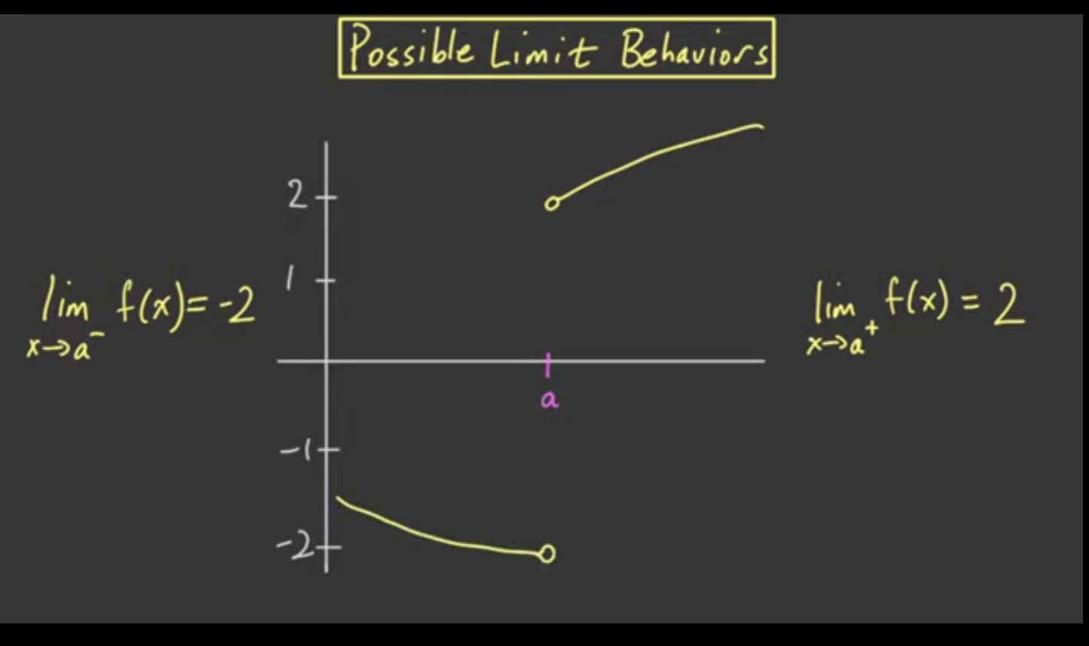

Limits that are agreeing

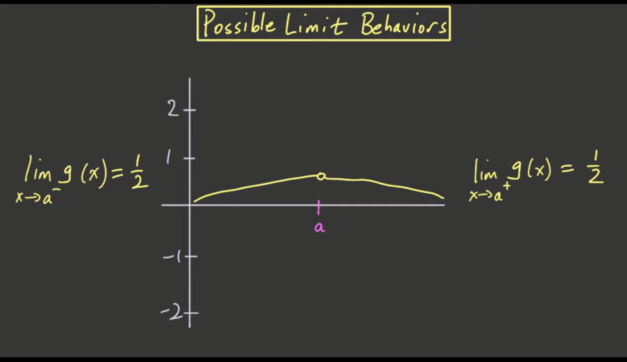

One-sided limits not existing (DNE = Does Not Exist)

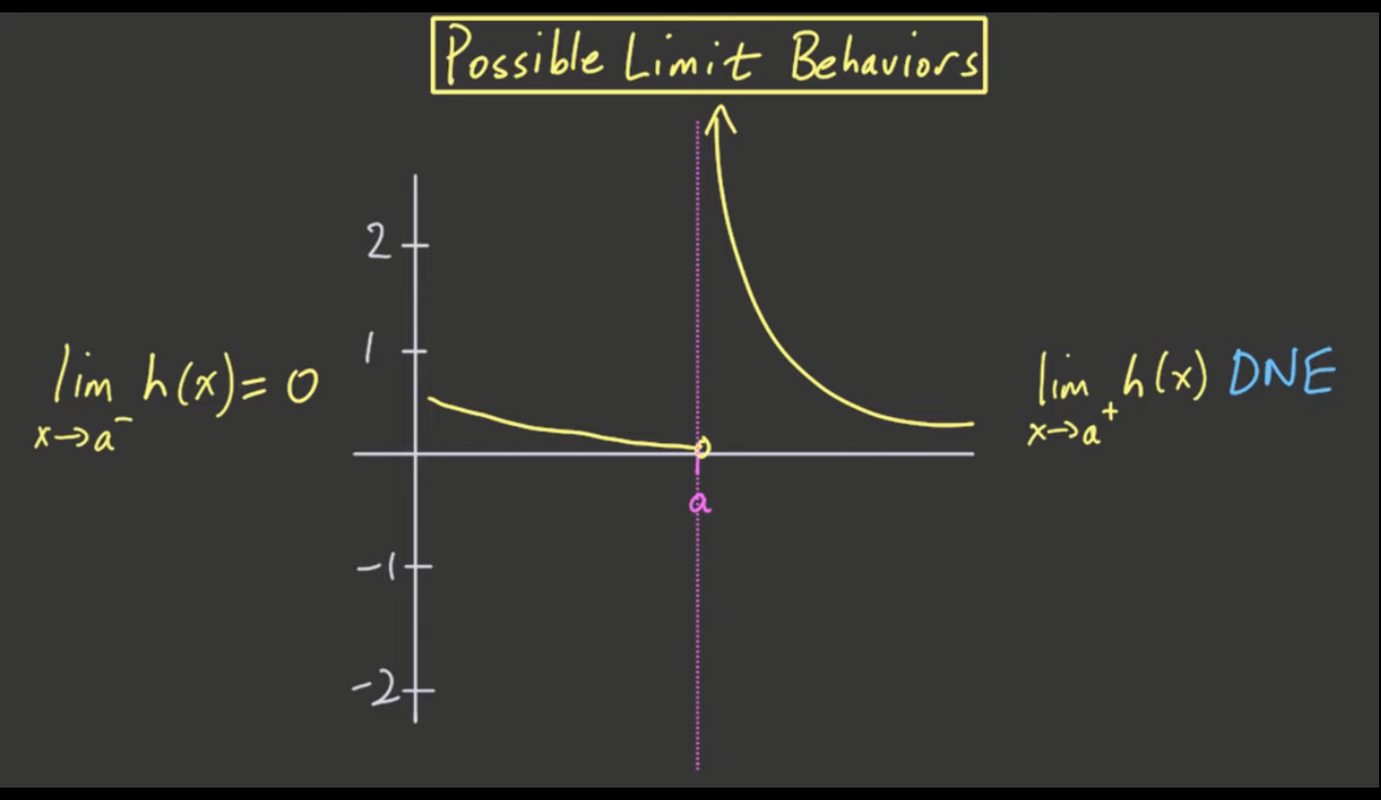

* Approaches 0 if limit is from the left
* Approaches +Infinity if limit is from the right
  + Asymptotic with line x = a

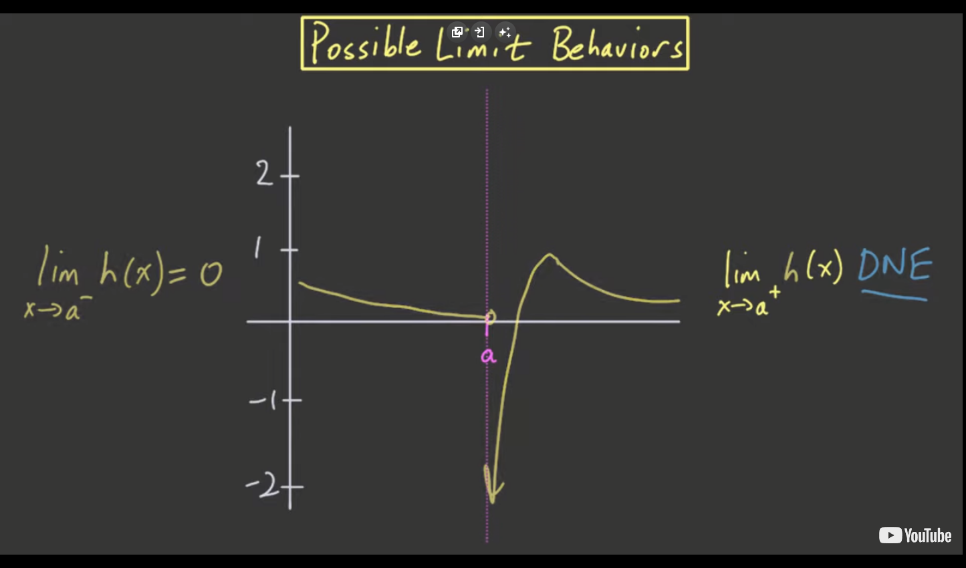

* Blew up at some point, approached infinity
  + Became asymptotic with the line x = a at some point while approaching

Bouncing limits (also DNE)

* Usually occurs in trigonometric functions
  + Sin, cos, …
* Limits are between +n and -n

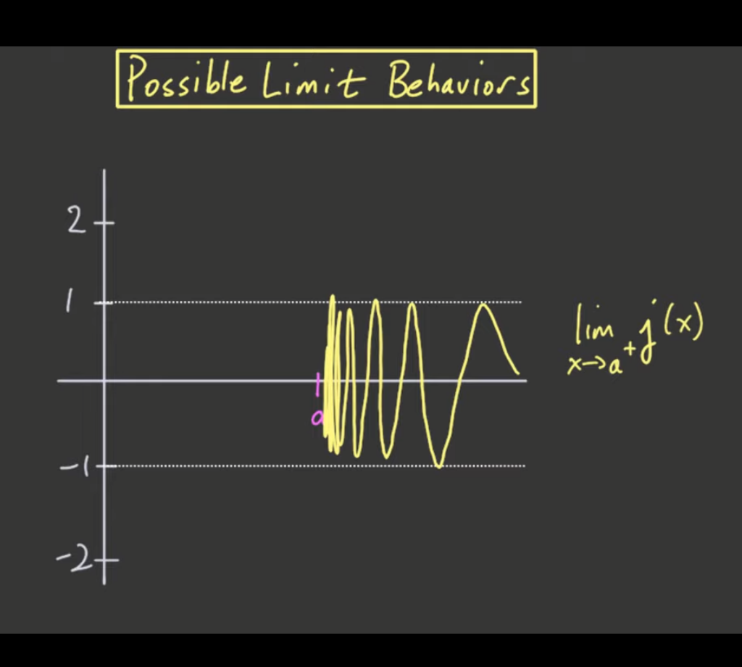

SUMMARY:

**There are many possible limit behaviors.**

1. The right-hand and left-hand limits may both exist and be equal.
2. The right-hand and left-hand limits may both exist, but may fail to be equal.
3. A right- and/or left-hand limit could fail to exist due to blowing up to ±∞ . (Example: Consider the function 1/x near x=0 .) In this case, we either say the limit blows up to infinity. We also say that the limit does not exist because ∞ is not a real number!
4. A right- and/or left-hand limit could fail to exist because it oscillates between many values and never settles down. In this case we say the limit does not exist.

More limit questions

